**Kase Scenarios**

**Orkla: Dragon Con Detective**

*Challenge 1*: find the name of the place closest to the Westin Peachtree Plaza in Atlanta, Georgia with a Coca-Cola Freestyle machine.

I start by looking up the location (The Westin Peachtree Plaza in Atlanta, Georgia) in Google Maps to get a general sense of the surroundings. Then, I Google for ‘Coca-Cola Freestyle machine Atlanta Georgia’, which gives as a first result a page on find freestyle locations on the Coca-Cola Freestyle website. On this page I am able to type in the location of the Westin Peachtree Plaza in Atlanta, Georgia and a map with all Coca-Cola Freestyle locations in a 5-mile radius appears. Zooming in at the location, I can see that the closest location with a Coca-Cola Freestyle machine is called FIREHOUSE SUBS.

*Challenge 2*: find the name of the place of the secret meet up that was planned by the Sherlock Holmes Fanclub during Dragon Con 2024.

Listening to the audio, the location is referred to as ‘outgoing bongo skip’. The speaker has a southern accent, but I don’t know if this is significant. I start by doing a Google search for ‘outgoing bongo skip’, and adding the exclusion criteria -kase and -orkla to the query, to prevent spoilers. This did not turn up anything useful. Then I Googled only bongo to see if there were any alternative meanings. I learned that bongo is a language, so I tried to translate the word ‘skip’ from English to Bongo, but this word was not found. Then I realized that the three words might describe symbols, so I looked at different symbolic fonts (wingdings and webdings) to see if I could find a bongo symbol, but I did not. I asked Orkla for a hint, which mentioned something about translating the words to affiliate to a location. I was still lost with this hint, so I simply Googled ‘translate words to locations’. The seventh result was an article by Wired about ‘what3words’, which sounded exactly what I needed. I then went to the website of what3words and entered the words ‘outgoing bongo skip’. This directed me to a Trader Vic’s in Atlanta Georgia.

*Challenge 3*: find the name of the bronze statue that is located to the right of this picture, out of sight.

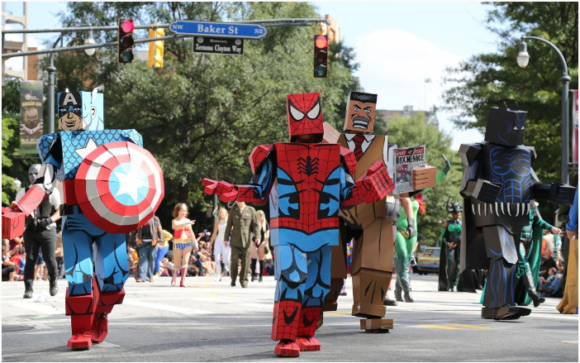

I start by zooming into the picture, and I can make out signs for Xernona Clayton Way as well as Baker Street. Typing Xernona Clayton Way into Google maps brings me again to Atlanta Georgia, parallel to Baker Street, so I’m on the right path. The sign on the picture for Baker Street is pointing to the left for NW and to the right for NE, suggesting that we should look at the North perspective of the Baker Street intersection with Peachtree Street. When I look at Google Street View on the intersection (picture from July 2024), I see the traffic lights but not the street signs on it. However, when I go slightly to the left, I do see the street signs on the traffic lights (picture from December 2021). On the right side I can actually see two bronze sculptures, although they are not marked in Google Maps. The statues are located on Truist Plaza, in front of the Dentons building. So I Google: ‘bronze statues Truist Plaza Atlanta Georgia’. On Google Pictures I can see the sculptures. When I click on the first result, I get to a peach that features an image of the plaque on the sculptures, which states the name: ‘Ballet Olympia’.

*Challenge 4*: Who designed this statue?

On the same page that I visited for challenge 3, it is explained that the statues are designed by John Portman.

*Challenge 5*: one of the clients of an insurance company is suspected to have faked a knee injury for monetary gain. This person may have attended the Boston Marathon some time between 2013 and 2018. They are male, late 30s and from Hong Kong. This is supposedly an image of them reaching the finish line. Confirm their name.

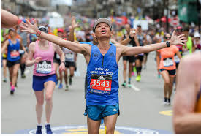

I start by doing a Google Reverse Image Search. I get 5 results with an exact match. The first result takes me to a Facebook page. I find the picture along with a post from Boston Marathon, which links to a page where you can search for bib numbers. This is the list for 2019 though, so it should not be relevant for our search. So I do a Google search for this website for the years 2013 to 2018: ‘site:http://registration.baa.org/ bib number numrange:2013-2018’. The first result is the page for 2014. Entering the bib number 3543 returns a female, so this is not the right person. Comparing this link to the one for 2019, I see that the link structure is the same ([http://registration.baa.org/[year]/cf/Public/iframe_EntryLists.cfm](http://registration.baa.org/%5byear%5d/cf/Public/iframe_EntryLists.cfm)). So for the remaining years, I try to fill in the years directly into the URL. This at least seems to work for 2013. It returns a male that is 27 years old, which is too young to fit the person we’re looking for. For 2015, it returns a male that is 40 years old and from Canada, while the person we’re looking for is from Hong Kong. For 2016, it returns a male, 38 years old and also from Canada. Finally, looking at 2017, we get a male, age 38, from Hong Kong. The name is Peter Yuen Man Ngai. Just to be sure, I also check 2018, which returns a female.